**Covid-19 Effects on Consumer Behavior**

Leonard Paul-Kamara

Wynne Zhang

Jessica Yunkyung Kwon

Dilia Yunusova

Sapiesi Tupou

**Our project looks at consumer food shopping habits changing amid the COVID-19 pandemic.**

Since the beginning of the year, the spread of the coronavirus disease and the actions taken in response to it drastically changed all aspects of our lives. As many places instituted stay-at-home orders in an effort to limit the spread of COVID-19, we wanted to look at the impact these stay-at-home orders might have had on the retail sectors and how each sector compared with each other. In the beginning of the pandemic, many wondered whether or not essential stores like grocery markets would remain open or stocked. As time passed, there have been a variety of changes to the way we shop and where we shop. Many of us have switched to shopping online as stores and plazas closed down. E-grocery tools like Instacart, Amazon Fresh, and Thrive have seen unprecedented popularity as consumers who want to minimize their exposure to coronavirus in a grocery store look to other shopping methods.

**Monthly US Confirmed Cases**

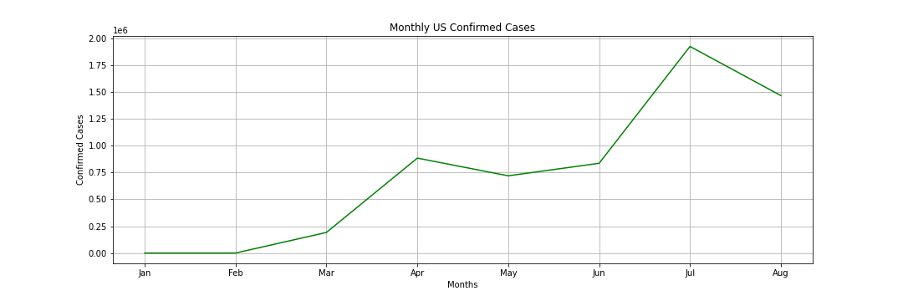

Before looking at any sales data, we analyzed the data of confirmed cases of COVID-19 in the United States. First cases of infection were identified at the end of January, with a visible spike from March to April. Then, due to lock down, the number of confirmed cases went down. Until June the increases were moderate, but from June to July the confirmed cases increased gradually and the amount of cases peaked in July. After taking a look at this timeline, we believe that consumer behaviour should have changed accordingly with the fluctuation in the number of confirmed COVID-19 cases.

**Retail Sales by Category**

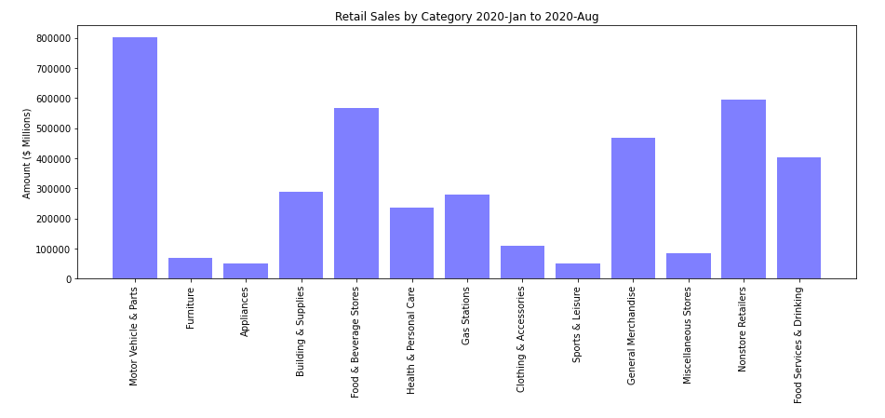

Retail Sales by Category: 2020-Jan to 2020-Aug

Prior to taking a dive into retail food shopping habits during the pandemic, we first had to take a broader look at how retail sales were doing overall since the year began. This bar graph depicts total retail sales figures sourced from United States Census data of the period between January 2020 and August 2020. This figure alone shows us that a large amount of retail sales falls within the “Motor Vehicle & Parts” sector which can be expected as the vehicle industry has much higher average transaction prices compared to the other sectors. Rather than simply looking at the retail sector with the highest sales figures, we wanted to focus more on the food-related categories seeing as how food is truly a necessity in our everyday life.

We will take a more detailed look at the “Food & Beverages” section, which includes supermarkets, grocery stores, and other food and beverage stores, as well as the “Food Services and Drinking” section which comprises restaurants and bars as well as other eateries. The sector containing grocery stores and food markets occupies about 14% of total retail sales during this period, while the food and drink service industry occupies about 10% of total retail sales.

**Percent Change of Retail sales**

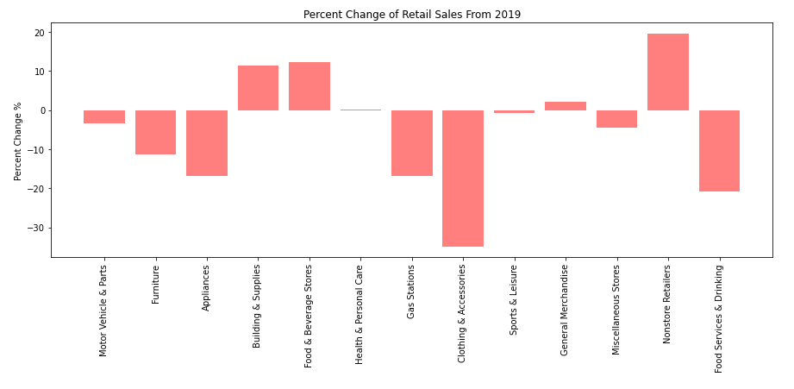

Percent Change of Retail Sales from 2019

While the figures from January to August of this year are important, that data alone will not give us enough insight on how the epidemic has impacted retail sales. To see how exactly retail sales were affected and to what extent, we compared the numbers of this year to the numbers from 2019, pre-COVID-19. The above graph depicts the percentage change in retail sales for the same months in 2019 and 2020. This year’s retail sales of clothing and accessories were most negatively impacted, showing a *-34.9%* change in sales compared to 2019. The food service and beverage sector, which includes restaurants, bars, cafes and the like, sees a sharp decrease in sales at *-20.9%* change. The food and beverage store sector that contains grocery stores and markets however, sees a *12.2%* increase in sales in comparison to the previous year. We can attribute the decreased performance in the restaurant industry to coronavirus related restrictions and consequences.

It’s no surprise that the food sector has been greatly impacted, but we were curious to see exactly how and what has changed because of it. Quarantine restrictions reduced demand from restaurants, which either closed down or were effectively turned into takeout establishments. We hypothesized that grocery sales heightened in the early months of 2020 as demand from grocery stores rose dramatically to meet customer demands. Consumers were unaware of how long they would be quarantined at home for and increased their purchase of food and grocery supplies during this period. If most restaurants are closed during this period, can we assume that most people are buying food from grocery stores? Are they physically going in to shop at grocery stores or are they acquiring groceries using other methods?

**Retail Grocery Sales**

To answer these questions, we pulled retail sales data from the United States Census government website and cleaned it to show us what the retail grocery sales figures look like within a 10 year period.

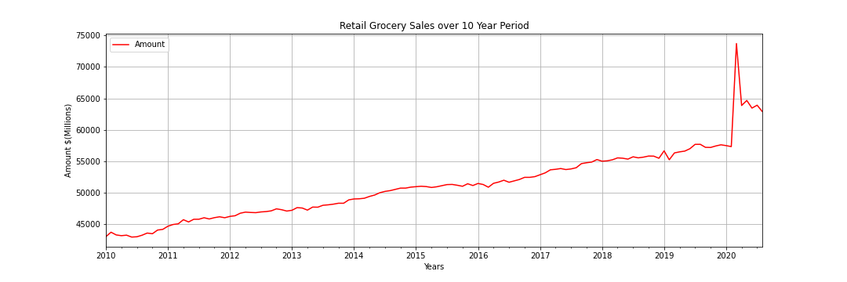

We see that since the year 2010, retail grocery stores have been doing pretty well and sales have been growing consistently. Some very significant changes occurred at the beginning of 2020 when we saw an extreme spike in sales. The line graph reaches its highest point between February to March, and it falls to about half of the peak figures by April, with a slight downward trajectory by August. The next graph zooms in on this time frame where the sales figures rise abruptly.

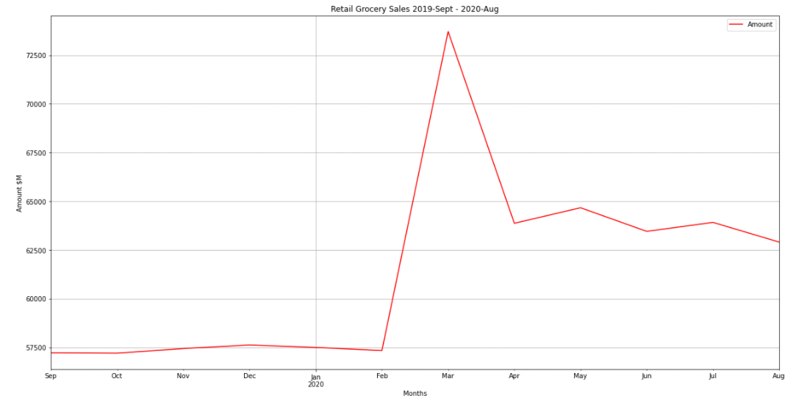

When taking a closer look at retail grocery sales within this year, we see that sales figures rise in February of 2020, reaching a climax in March and falling sharply by April. There were minor fluctuations after April, but sales have been generally consistent with a slight downward trend. However, the numbers in August are still much higher than what they were when sales spiked in February.

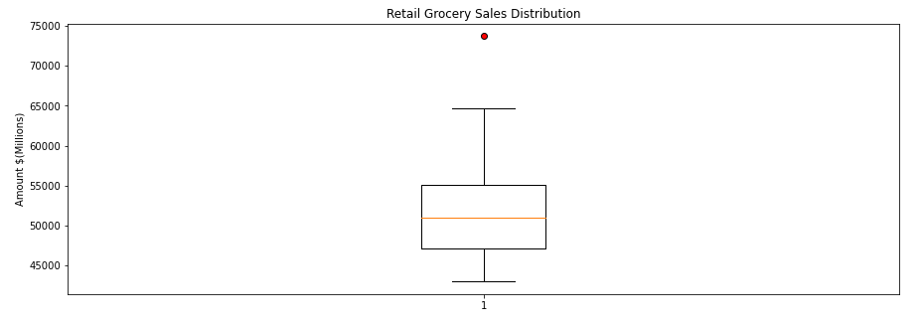

This box plot on retail grocery sales indicates that March of 2020 is an outlier month. We believe what we see here is panic buying and stockpiling in March, which reduced in April as many more restrictions were put in place and consumers were less worried about the shortage of grocery essentials in an unexpected pandemic. This also reflects a few main factors related to government stay-at-home orders, including government mandated closures of schools and restaurants, driving a significant percentage of consumer food spending from physically eating out to purchasing food to be eaten at home. After confirming the impact quarantine and COVID-19 had on retail grocery store sales, we wanted to know whether or not there was an association between the number of confirmed coronavirus cases and these grocery sales figures.

**Retail Grocery VS Covid**

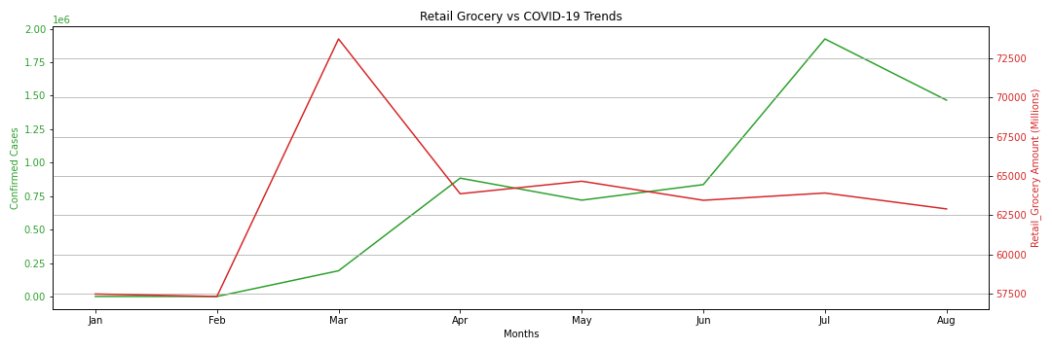

To do this, we stacked retail grocery sales trends against the number of confirmed cases. The steepness of the rise of grocery sales makes an interesting comparison against the more gradual rise of COVID cases. In March, the two lines have an inverse relationship- showing that although the number of infected individuals was rising at a more rapid rate, there was a decline in retail grocery sales. We could theorize that a large number of people visiting retail grocery stores and supermarkets resulted in a sharp increase in COVID cases, as seen from March to April. More sick people encouraged consumers to reduce retail grocery shopping, explaining the decrease in grocery sales from March to April. Higher number of COVID cases could have encouraged many to resort to e-grocery shopping, or purchasing food through other methods. Retail grocery sales stabilized after April, but it still recorded higher numbers than previous years’ sales. The number of confirmed cases spike again in June, but we see that grocery sales are on a slight decline.

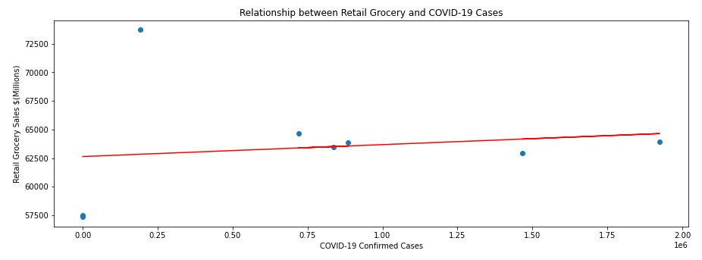

When we first looked at the previous graphs, we thought that there would be some correlation between retail grocery trends and the number of confirmed coronavirus cases. We put this to the test calculating a correlation coefficient. Contrary to what we thought, the two factors have little to no linear correlation at a correlation coefficient of *0.14*.

We did however want to look more closely at the fall of retail grocery sales during the time period in which confirmed COVID cases were rising. We thought - if people are still buying groceries but not in the conventional method of going into a retail supermarket or grocery store, how are they doing it? This is where we turned to look at the e-commerce sector and the growing market for e-grocery and grocery delivery services. We expect that this sector has shown exceptional growth due to the coronavirus outbreak. Once a luxury, services like Instacart and Amazon Fresh have turned into essential seemingly overnight. We are curious whether or not COVID-19 initiated a permanent shift towards contactless shopping and if grocery delivery services will become mainstream in the long run.

**E-Commerce**

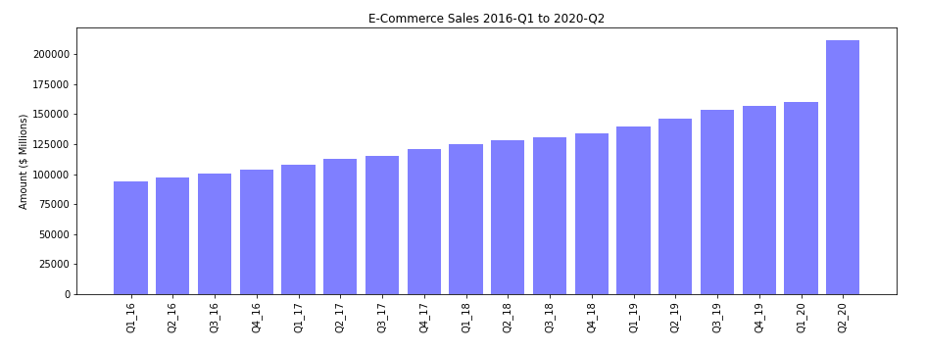

The first thing we did was take a look at how e-commerce as a whole has changed recently. Above bar graph shows e-commerce sales figures from Q1 of 2016 to Q2 of 2020, which is around April to the end of June this year. Between Q1 and Q2 of 2020, there was a *44.5%* growth in e-commerce sales.

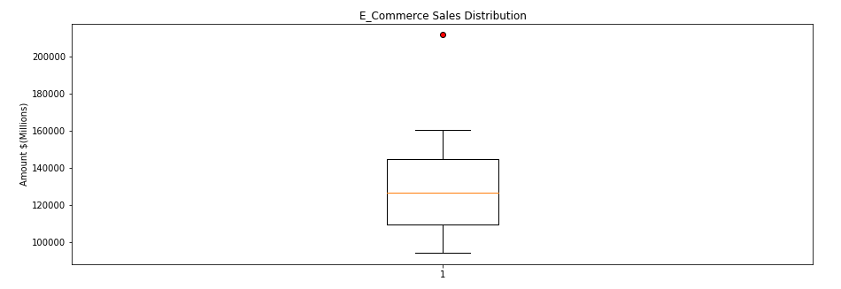

A box plot shows that there is a clear outlier - Q2 of 2020. We then proceeded to compare total e-commerce sales to total retail sales to see if e-commerce really had become a replacement to retail options.

**Total Retail vs Total E-Commerce**

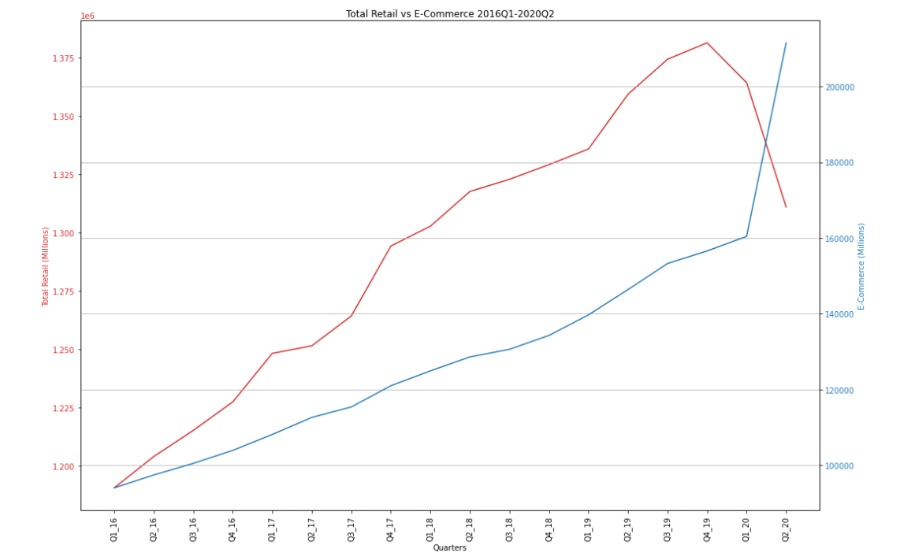

By taking retail sales data that we analyzed earlier and putting it against e-commerce sales data, we can observe that e-commerce had been steadily increasing through the years but spiked upwards in Q1 of 2020. In the same quarter, we see a sharp decrease in retail sales indicating a change in consumer behavior. This was between January and April of 2020, between the beginning and peak of coronavirus lockdown procedures. Even after the reopening of more retail stores in Q2 of 2020, we continue to see an increase in e-commerce sales and retail sales continue to plummet. Based on this, we can propose that the more specific grocery sale trends will look similar.

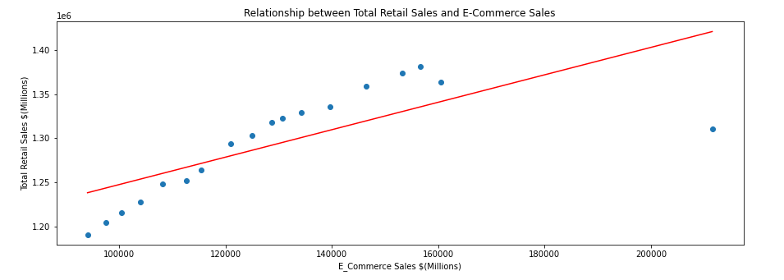

A Pearson’s correlation coefficient of *0.74* between total retail sales and e-commerce shows that in general, there has been a positive linear correlation between the two variables up until 2020. However, the single outlier on the right tells us that COVID-19 has forced a huge change in consumer shopping choices.

**Retail Grocery vs E-Grocery**

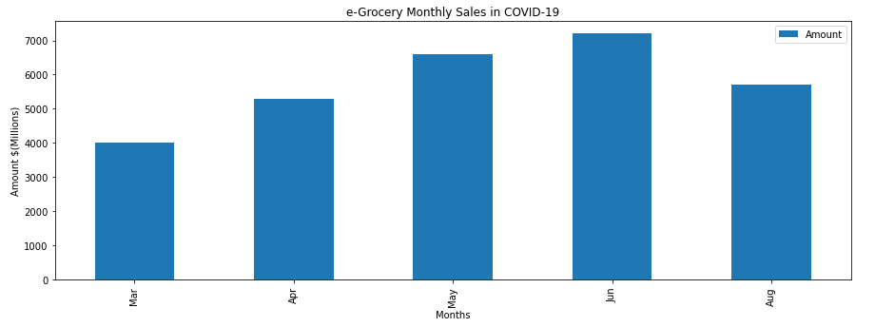

To look at groceries specifically, we created a bar graph for e-grocery monthly sales during COVID times. Unfortunately our data sample was limited, and we were only able to obtain figures for March, April, May, June, and August. The elevated e-grocery sales figures in May and June correspond to the peak in total e-commerce sales from Q1 to Q2 of 2020.

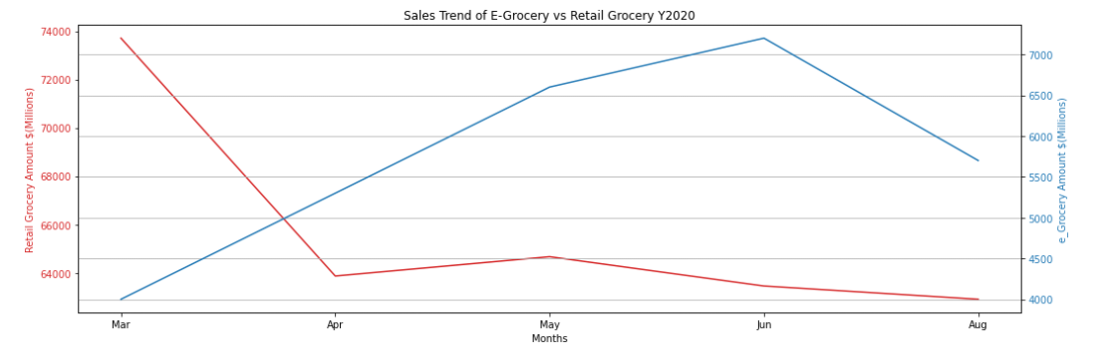

This comparison is done between the same corresponding months in each data set due to the limitations of obtaining data for the months of January, February and July. Therefore we dropped the data for those three months in the retail grocery dataset to make a more accurate comparison with e-grocery sale data. A point of intersection between the two lines occurs between March and April of 2020. We attribute this to the shelter-in-place requirements and an increased demand for the minimization of exposure to coronavirus in public settings such as grocery stores. The plateau in new COVID-19 cases from April to June overlaps with the steady rise of e-grocery sales from April to June.

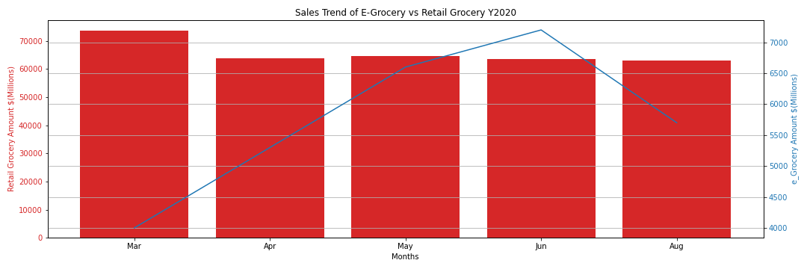

Similar to the previous graph, this graph depicts sales volume of retail grocery and a trend in e-grocery. While retail grocery sales appear to drop from March to April, e-grocery on the other hand witnessed a steep rise until June when it recorded the highest sales. E-grocery then experienced a decline just after its peak in June, but sales in August still remain above March figures. The decrease can be attributed to a multitude of factors, such as the question of whether or not e-grocery costs are sustainable for most consumers, and also the reopening of the food service and beverage sector for takeout options. As of August, retail grocery is still not able to recover from the decline in sales.

**Conclusion and Predictions**

It is no surprise that the occurrence of the pandemic has changed consumer behavior. Through our research and data analysis, we see that there is no direct linear correlation between retail sales and the number of confirmed COVID-19 cases in the U.S. Data shows that while e-commerce flourished like never seen before, retail sales have suffered a colossal blow. As of Q2 of 2020, retail sales figures have fallen to what they were in Quarter 1 of 2018, and looks to continue to be declining. The coronavirus pandemic has no doubt accelerated the speed of the online shopping trend, and most likely forced businesses of all industries to go online and offer contactless, easy-to-access options to stay competitive. However, the moderate decrease in sales of e-grocery specifically hints that consumers still prefer personally shopping for groceries in store rather than online or through an app. We believe that as more time passes and consumers transition to post-COVID times, there will again be a positive linear correlation between retail sales and e-commerce sales, as it has been historically. There is no doubt however that recent advancements in e-commerce and e-grocery will blend technology with our daily lives even more, hopefully increasing ease of access and making our lives more convenient. Since it has only been 9 months since the beginning of the COVID-19 global pandemic, the data that is available is still limited. We believe that after more time, we can be even more precise with our analysis and prediction.

**Sources**

[Monthly Retail Trade, Main Page - US Census Bureau](https://www.census.gov/retail/index.html)

[Advance Retail Sales: Grocery Stores (RSGCS)](https://fred.stlouisfed.org/series/RSGCS)

[United States Corporate Profits | 1950-2020 Data | 2021-2022 Forecast | Calendar](https://tradingeconomics.com/united-states/corporate-profits)

[Corporate Profits | US Bureau of Economic Analysis (BEA)](https://www.bea.gov/data/income-saving/corporate-profits)

[Online Grocery Scorecard: August 2020](https://www.brickmeetsclick.com/august-2020-scorecard--online-grocery-market-rebalancing-after-covid-spike).

Johns Hopkins Coronavirus Resource Center

**Link To Our Presentation**

<https://www.canva.com/design/DAEJyd4ucz8/_zsxYH3pqVscqIoqKmu3Cw/view?utm_content=DAEJyd4ucz8&utm_campaign=designshare&utm_medium=link&utm_source=sharebutton>

**Presentation Order**

Slide 1 - 6 intro & monthly covid cases, retail sales by category: **dilia**

Slide 8 - 10 retail sales trends now & last 10 yrs: **wynne**

Slide 11 - 14 retail grocery vs. covid: **jessica**

Slide 15 - 17 total retail vs total e-commerce: **sapi**

Slide 18 - 21 retail grocery vs. e-grocery & conclusion: **leonard**